**PERSONAL BLOG ON IBM CLOUD STATIC WEB APPS**

 SUBMITTED BY

J.THAMAYANTHI

B.UDHAYA KUMAR

M.UDHAYA KUMAR

S.VIJI

V.SUDHARSHAN

PHASE 3 SUBMISSION DOCUMENT

PHASE 3: Development Part 1

Topic: Design the website layout using HTML and CSS

**Problem statement:**

* **Create a personal travel blog hosted on IBM Cloud Static Web Apps.**
* **Share your travel adventures, tips, and captivating photos with the world.**
* **Use IBM Cloud Static Web Apps to easily update your blog and document your journeys.**
* **Inspire others to explore the beauty of the world and forge unforgettable memories!.**

**Personal travel blog on IBM cloud static web app**

1. **Personal travel blog on IBM cloud static web app**

* **If you don't have an IBM Cloud account, sign up for one. You'll need it to host your static web app.**

1. **Create a Static Website:**

* **Design and develop your travel blog as a static website. You can use HTML, CSS, and JavaScript to create your web pages and content.**

1. **Choose a Framework:**

* **Consider using a static site generator like Jekyll, Hugo, or Gatsby to make it easier to manage your content and generate web pages.**

**4. Version Control:**

* **Use Git to track changes in your project. GitHub, GitLab, or Bitbucket are popular platforms to host your project's repository.**

**5. Version Control:**

* **Use Git to track changes in your project. GitHub, GitLab, or Bitbucket are popular platforms to host your project's repository.**

**Here's how to set it up:**

* **Log in to your IBM Cloud account.**
* **Create a new Static Web App service.**
* **Follow the instructions to connect your GitHub repository (where you've stored your website code) to the IBM Cloud service.**
* **Configure the build and deploy settings.**
* **Deploy your website.**
* **Domain Name (Optional):**
* **If you want a custom domain name for your travel blog, you can purchase one and configure it to point to your IBM Cloud Static Web App.**

**6. Content Management:**

* **Consider using a Content Management System (CMS) like Netlify CMS or Forestry to make it easier to add and update your travel blog content.**

**7. Optimize for Performance:**

* **Optimize your website for speed and performance. Use content delivery networks (CDNs) to serve your site faster to users.**

**8. Security:**

* **Implement SSL (HTTPS) to secure your website. IBM Cloud often provides free SSL certificates.**

**9. Continuous Updates:**

* **Keep your blog updated with new travel experiences and stories.**

**Design the website layout using HTML and CSS.**

**HTML – Hyper Text Markup Language**

* **HTML is the standard markup language used to create a web pages and documents for display on the World Wide Web .**
* **It consists of a set of tags and attributes that define the structure and content of a web page, such as headings ,paragraphs, links, images and more .**
* **HTML is the fundamental building block of web pages and is interpreted by web browsers to render the visual elements and structure of a webpage.**

**CSS – Cascading Style Sheets**

* CSS is a style sheet language used in web development to control the presentation and layout of HTML documents .
* It is used to define the visual styling, including elements like colors, fonts , spacing ,and positioning of elements on a web page .
* CSS allows web developers to separate the structure (defined by HTML) from the presentation (defined by CSS), making it easier to maintain and update the visual aspects of a website .
* CSS styles can be applied globally or selectively to specific HTML elements , providing a consistent and visually appealing design for web pages .

**SAMPLE PROGRAM FOR PERSONAL TRAVEL BLOG USING HTML AND CSS**

<!DOCTYPE html>

<html>

<head>

    <meta charset="UTF-8">

    <title>My Travel Blog</title>

    <link rel="stylesheet" type="text/css" href="style.css">

</head>

<body>

    <header>

        <h1>YAVISHAN Travel Adventures</h1>

    </header>

    <style>

        /* Reset some default styles */

body, h1, h2, h3, p {

    margin: 0;

    padding: 0;

}

body {

    font-family: Arial, sans-serif;

    background-color: #30b6ce;

}

header {

    background-color: #333;

    color: #fff;

    text-align: center;

    padding: 20px;

}

nav ul {

    background-color: #333;

    list-style-type: none;

    padding: 0;

    text-align: center;

}

nav li {

    display: inline;

    margin: 10px;

}

nav a {

    text-decoration: none;

    color: #56d356;

}

main {

    max-width: 800px;

    margin: 20px auto;

    padding: 20px;

    background-color: #f8a7a7;

    border-radius: 5px;

}

.blog-post {

    margin-bottom: 20px;

    padding: 10px;

    border: 1px solid #da1cca;

    border-radius: 5px;

}

footer {

    background-color: #333;

    color: #d67e0c;

    text-align: center;

    padding: 10px;

}

/* Add more CSS styles to customize your blog's appearance */

    </style>

    <nav>

        <ul>

            <li><a href="#home">Home</a></li>

            <li><a href="#blog">Blog</a></li>

            <li><a href="#about">About</a></li>

            <li><a href="#contact">Contact</a></li>

        </ul>

    </nav>

    <main>

        <section id="home">

            <h2>Welcome to My YAVISHAN Travel Blog</h2>

            <p>Explore the world with me and discover exciting destinations and hidden gems.</p>

        </section>

        <section id="blog">

            <h2>Latest Blog Posts</h2>

            <article class="blog-post">

                <h3>Exploring the Magical City of Paris</h3>

                <p>Date: JULY 23 , 2023</p>

                <p>Paris, the city of love and lights, is a place you must visit at least once in your lifetime....</p>

            </article>

            <!-- More blog posts go here -->

        </section>

        <section id="about">

            <h2>About Me</h2>

            <p>Hi, I'm MANIKANDAN, an avid traveler with a passion for exploring new places and sharing my adventures with the world. I hope my blog inspires you to embark on your own journeys.</p>

        </section>

    </main>

    <footer>

        <section id="contact">

            <h2>Contact Me</h2>

            <p>If you have any questions or want to connect, you can reach me at [[massmani@gmail.com](mailto:massmani@gmail.com)].</p>

        </section>

    </footer>

</body>

</html>

**Sample output:**

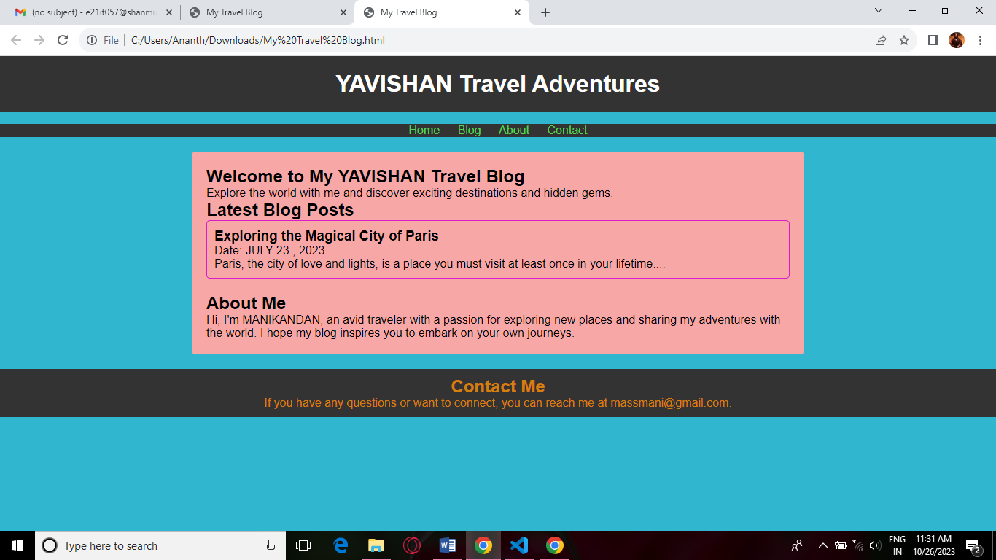

ss